

**Loyola / Notre Dame Library**

**Assignment Descriptions**

**EN200 – Major Writers – Library Research Assignment**

**Purpose:** To prepare students for final research projects in their EN200 courses and introduce them to MLA International Bibliography, a core database for literature research.

**Learning Outcomes:** After completing the assignment, students will be able to:

* Find literary criticism using the library catalog and MLA International Bibliography
* Cite a book and journal article using MLA style
* Distinguish between a book, chapter in a book, and journal article citation
* Describe how to access a work of literary criticism, whether online, at the library, or via InterLibrary Loan

**Format:** Students complete a take-home assignment made up of five parts (20 pts.)

1. Using the catalog, find one print book of literary criticism on a specified author. Verify that the book is at LNDL (rather than at another consortium library), then write the call number and full MLA citation. (5 pts.)

2-a. Using MLA Bibliography, demonstrate the ability to use Boolean operators, truncation, subject searching, and search limits to find scholarly articles on a given research topic.

*e.g., Compare the use of humor in* A Connecticut Yankee in King Arthur’s Court *and* The Adventures of Huckleberry Finn *by Mark Twain.* Print search results, including search history. (5 pts.)

2-b. Evaluate search results and circle 2-3 relevant scholarly journal articles. (2 pts.)

2-c. Select one relevant article and cite in MLA format. (3 pts.)

3 & 4. Given two MLA citations:

1. Identify the item’s format—book, book chapter, or journal article
2. Locate the item using the library catalog or journal finder. (4 pts.)

5. Answer the following: “What would you do if neither the library nor the consortium own

the book or article you need?” (1 pt.)

**Example: Question 3**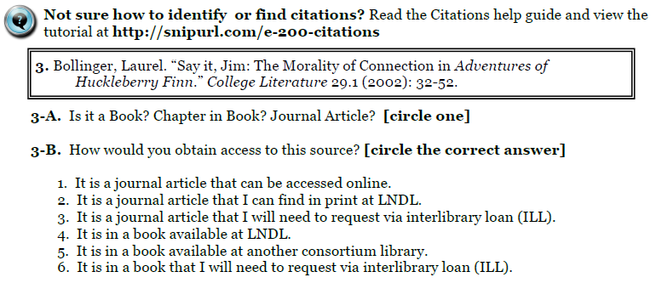

**NUR402 – Professional Nursing Practice – Clinical Practice Question**

**Purpose:** To introduce first-semester students in the RN-to-BSN program to the library resources that support evidence-based practice, which forms the basis of their curriculum, with a focus on using the CINAHL (Cumulative Index to Nursing and Allied Health Literature) database.

**Learning Outcomes:** After completing the assignment, students will be able to:

* Construct a researchableclinical question that focuses on nursing practice
* Build a search strategy in CINAHL and broaden or narrow the results as needed, using tools such as Boolean operators, truncation, and limits
* Identify primary and secondary research articles among results

**Format:** The assignment spans three weeks of this six-week course.

**Week One:** Students formulate a clinical question related to their nursing experience and post the question to a discussion forum on Joule (CMS). The instructor comments on the practice-related aspects of the question (e.g., a particular intervention to research). The librarian then advises on the “researchability” of the question, and gives suggestions as to revising the question and/or search strategy.

**Week Two:** The librarian visits class to conduct an instruction session, followed by 30-60 minutes spent helping students search individually on their own topics.

**Week Three:** Students print their CINAHL search history; the final search must produce a set of 10-25 search results. These 10-25 citations must be written in APA format. Students include a three-paragraph reflection of their experience developing the questions and searching in CINAHL.

**Sample Exchange in Joule Discussion Forum:**

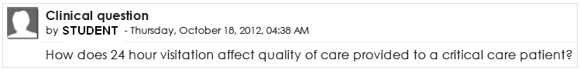

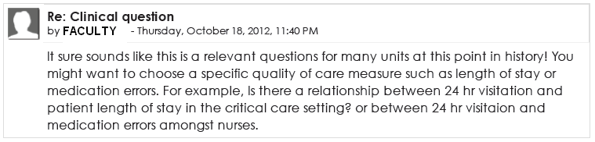

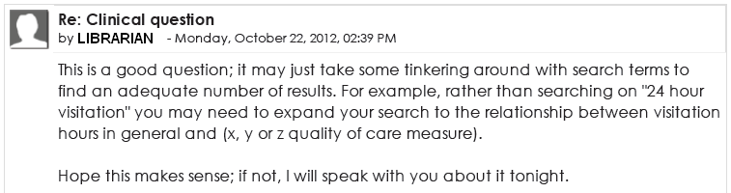

**Pharmacy Care Lab Pre- and Post- Assignments**

**Purpose:** The pre-class assignment is designed to introduce students to using the library catalog to locate pharmacy books in preparation for a more complicated in-class activity. The post-class assignment reinforces key concepts that are covered during class regarding searching PubMed and provides an opportunity for the librarian to give individualize feedback to students.

**Learning Outcomes:** After completing the assignment, students will be able to:

**Pre-class Assignment**

* Use the library catalog to locate print and electronic books
* Access print books in the circulating and reference collections
* Access an electronic book online and navigate to a specific chapter

**Post-class Assignment:**

* + - Demonstrate the ability to search for a specific topic in PubMed through selecting appropriate key terms, combining them using AND and OR, applying limits
    - Define automatic term mapping in PubMed and explain one benefit and weakness of this feature
    - Identify relevant journal articles on a given topic after performing a search in PubMed

**Format:**

**Pre-class Assignment (10 pts)**

In this 30-minute assignment, students are given the name of three core pharmacy books (an e-book, a reference book, and a book in the circulating collection) that they must locate and use to answer three simple questions. Three versions of the assignment are distributed to prevent cheating. Sample question:

1. Use the library catalog to locate the following book:

***Title:* Pharmacotherapy: a pathophysiologic approach**

***Editor:* DiPiro, Joseph T**

***Year:* 2011 (must be the 2011, 8th edition)**

Answer the following:

1. What is the call number for this book?:
2. Is this edition of the book found
   * Online?
   * In the Health Sciences Reference Collection
   * In the Main Health Sciences Collection
3. Locate this book ***in*** the library. According to pg. 952, what is one treatment option for cognitive symptoms in Alzheimer’s Disease?

**Post-Class Assignment (10pts)**

In this 30-minute assignment students are given a research question that they must search in PubMed. They are asked to find three relevant journal articles from their results. Students are also asked to define “Automatic Term Mapping” and write one benefit and one drawback to this PubMed feature.

**Research Question:**

Many patients who suffer from lower back pain seek alternative treatments such as yoga or acupuncture to manage their pain. Does the research show these **two** treatments to be effective?

Find articles to answer this question that are from the last 10 years and focus on adults ages 19 and above.

**Grading Rubric Given to Students for the Post-Class Assignment**

|  |  |  |  |
| --- | --- | --- | --- |
| **Rubric (Total 10 pts)** | | | |
| **Learning Outcomes** | **Beginning** (no credit) | **Intermediate** (half credit) | **Proficient** (full credit) |
| **Key Terms (2 pts)** Student identifies useful key terms from a research question. | Student does not choose productive key terms or student types the entire research question or phrase into the search box. | Student uses important key terms, but also uses extraneous terms. | Student identifies and uses only the most important key terms from the research question. |
| **Connectors (2 pts)**  Student combines key terms in a search using AND & OR effectively. | Student uses AND/OR connectors incorrectly or does not include connectors in search statement. | Student connects terms with AND, but uses OR incorrectly. | Student connects key terms with AND & OR correctly. |
| **Limits (2 pts)**  Student applies appropriate limits—such as date and age range—to a search. | Student does not apply required limits or applies inappropriate limits. | Student applies some useful limits but misses one or more important limits. | Student chooses appropriate limits and applies them to the search. |
| **Relevancy (2 pts)**  Student evaluates the search results and from this list identifies journal articles that are relevant to the research question. | One or none of the journal articles identified from the results list are relevant to the research question. | Two of the journal articles identified from the results list are relevant to the research question. | All three of the journal articles identified from the results list are relevant to the research question. |
| **Automatic Term Mapping (2 pts)**  Student defines automatic term mapping and explains challenges of this feature. | Student’s definition is unclear and drawbacks of this feature are missing. | Student defines automatic term mapping, but is unable to explain one drawback of the feature. | Student successfully defines automatic term mapping and explains one drawback of the feature. |